Lesson 10: Food is medicine
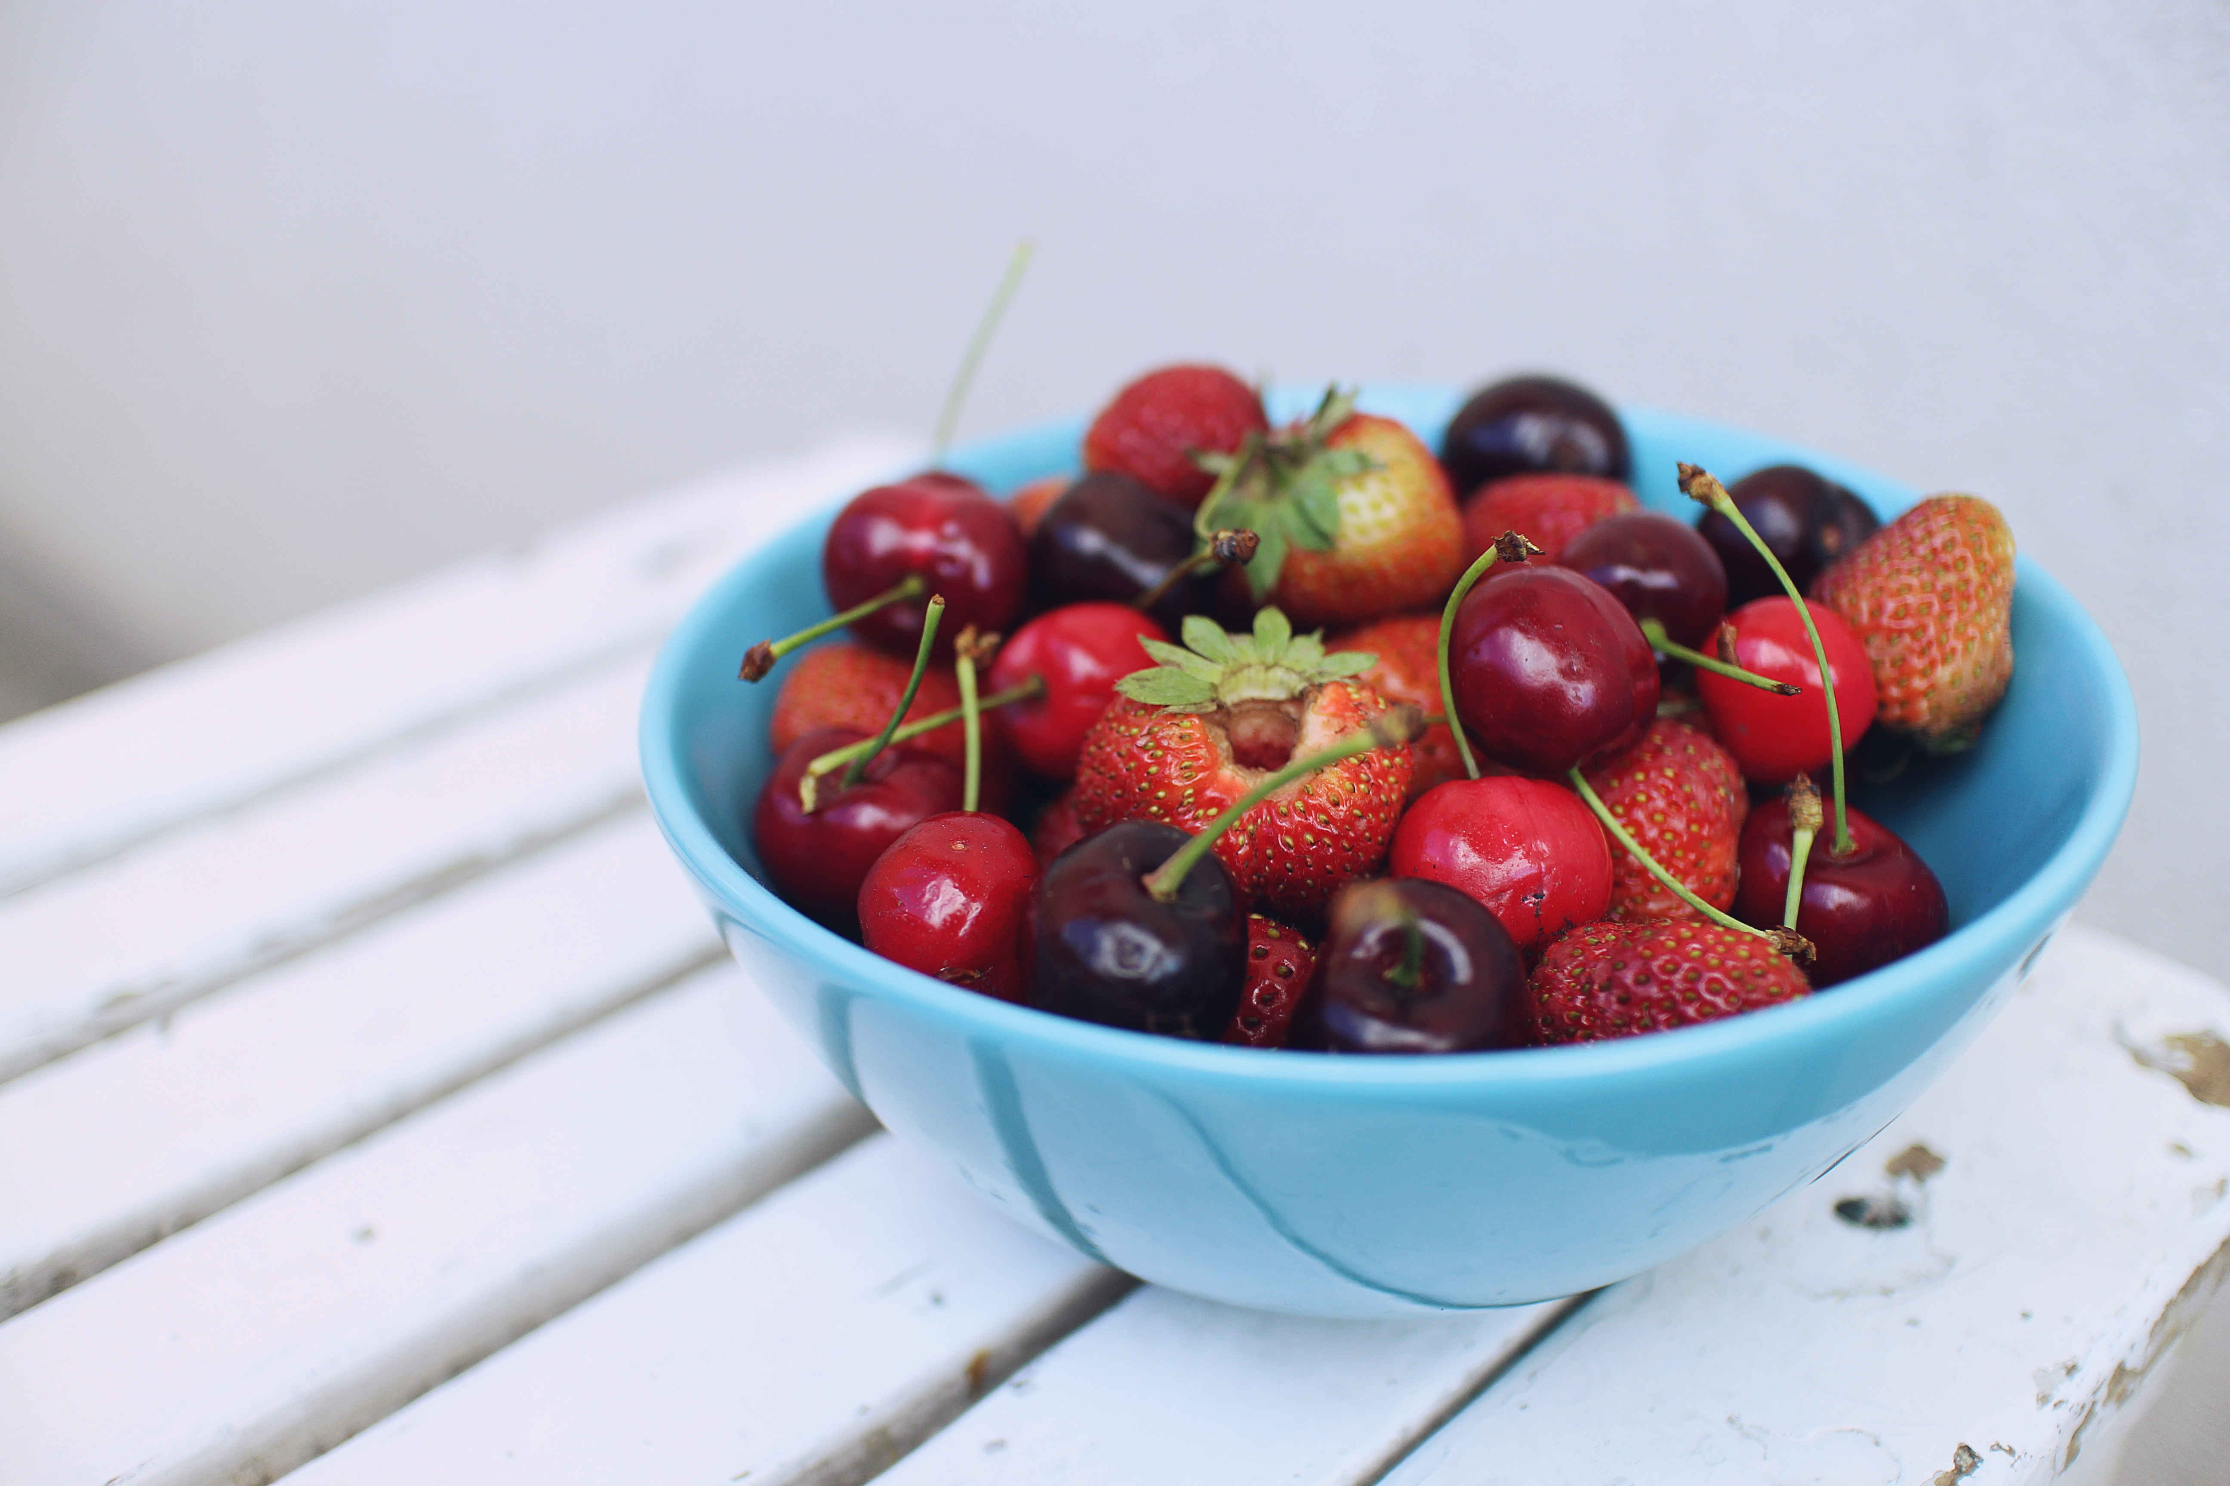
What you eat each day has a huge effect on your body and mind. Unfortunately, our nutrition often gets overlooked, especially when you're stressed, tired, and hungry.
At moments like this, we reach for sugary, caffeinated or alcoholic foods—thinking we’ll get a burst of energy. But, that crash isn’t far behind. I believe knowledge is power–and that if you truly understand what happens inside your body when you eat these foods, you’re more apt to make healthy choices.
Foods that may increase stress
Sugar. When you eat sugary foods like candy, ice cream, alcohol, pasta, baked goods or processed carbs, the sugar is absorbed quickly into the bloodstream. This causes an initial high or surge of energy. But as the body increases its insulin production to remove the sugar from your bloodstream, you're left feeling tired and low. You reach for more junk food and are stuck in a sugar craving cycle. If left unchecked, diabetes can develop as the pancreas, which produces the insulin, can’t mop up all the sugar flooding your body.
That’s not all that happens. As you know by now, when you are stressed, your body produces cortisol. But, did you also know that cortisol causes cravings for sugary and fatty foods, which leads to weight gain? To add insult to injury, cortisol also:
- Helps create fat cells,
- Enlarges the size of fat cells, and
- Increases the amount of fat tissue your body hangs onto – especially that stubborn belly fat.
And we’re not done yet. Because visceral (belly) fat tissue releases cortisol when you are stressed, the more belly fat you have, the more cortisol your body releases and the more sugar you crave. It’s like the sugar cycle on steroids!
Artificial Colors, Dyes, Sweeteners, GMOs and Chemical Preservatives. Or as I like to call them, “Franken Foods”. These food-like substances (because they are not real food!) are amongst the worst things you can put in your body. At best, they trigger inflammation in your body that can lead to weight gain and joint pain. At worst, they have been linked to cancer and tumors, neurological disorders (like hyperactivity, MS, autism, epilepsy), infertility, birth defects, thyroid disorders, mood disorders and more. With so many fresh, healthy, organic alternatives, why risk it?
Alcohol. Some people drink alcohol because it seems to ease stress, but this effect is only temporary. Besides hindering your sleep, alcohol is known to be a depressant.
Caffeine. Love it or hate it, caffeine is controversial. It’s been shown to inhibit levels of serotonin in the brain, which can lead to depression and irritability. Caffeine increases your heart rate, raises your blood pressure and puts your body into "fight or flight" mode – all physical stressors. Over time, excess coffee consumption can also cause adrenal fatigue. But, new research shows caffeine, in the form of organic black tea or coffee, may offer some benefits because it has antioxidant properties. Evidence suggests caffeine may offer protection against some cancers, type 2 diabetes, heart disease and Alzheimer’s and may enhance athletic performance.
Bottom line: I recommend that if you want to have a cup of black, high quality coffee or tea, go for it. But buy organic to avoid pesticides and grind your own coffee beans to ensure freshness and maximum health benefits.
Foods that help alleviate stress
Instead of causing huge mood and energy swings, some foods can make us feel calm. A well-balanced, healthy diet can help counter the impact of stress by boosting the immune system and lowering blood pressure.

A great way to start your day is with water. Remaining properly hydrated is incredibly important to our health, including the health of our minds. Having a clear mind will allow you to feel much better overall. So instead of grabbing coffee first thing in the morning, have a glass of room temperature water first. Add some fresh lemon juice to rev up your metabolism and give your liver an energy kick.
Other great stress-reducing foods include:
Complex carbs. Gluten-free oats, sweet potatoes, brown rice, peas, beans and quinoa are loaded with fiber, which helps stabilize blood sugar levels and leaves you feeling balanced and less hungry. In addition, replace comfort foods such as Quaker oatmeal with healthier, gluten-free steel cut oats, which boost levels of “the happy brain chemical” serotonin. Even better – mix in some nuts, almond butter or almond milk, or coconut to add some healthy fats which will leave you feeling satiated for longer.
Oranges. Vitamin C found in oranges helps reduce stress hormones, while strengthening your immune system.
Grass-fed beef. A deficiency in B vitamins, such as folic acid and B12, can trigger depression in some people. Foods that are rich in B vitamins tend to ward off anxiety--these include beef, chicken, turkey, and eggs.
Fatty fish. Omega-3 fatty acids, found in fish such as salmon, anchovies and sardines, can prevent surges in stress hormones and may help protect against heart disease, depression, and premenstrual syndrome (PMS).
Nuts. Almonds, walnuts, pistachios and cashews are a good source of healthy fats, which lower cholesterol and inflammation in the body. Nuts are also an excellent source of vitamins B and E. And, they contain zinc and iron--key nutrients for maintaining a balanced mood and energy.
Chocolate. Pure, dark chocolate without added sugars or milk reduces cortisol, the stress hormone that causes anxiety symptoms. Cocoa can release serotonin and improve your mood.
Berries. Berries such as blueberries, strawberries and blackberries are rich in vitamins and phytonutrients (plant nutrients), with a variety of antioxidants that are considered extremely beneficial for relieving stress and balancing your mood.
Avocado. One of the best ways to reduce high blood pressure is to get enough potassium, and half an avocado has more potassium than a medium-sized banana.
Asparagus. These slender stalks are high in folate, which is essential for keeping you calm and collected.
Green leafy vegetables. Spinach, kale, swiss chard, and collard greens contain magnesium, a mineral which promotes relaxation. Additionally, greens help to protect your mood by fighting free radicals.
Yogurt. The bacteria in your gut may contribute to stress. Research has shown that the brain signals to the gut, which is why stress can inflame gastrointestinal symptoms. A 2013 UCLA study among 36 healthy women revealed that consuming probiotics in yogurt reduced brain activity in areas that handle emotion, including stress. Probiotics can improve the immune system, help alleviate depression, and lower anxiety. Look for plain (hormone- and antibiotic-free, if possible) yogurt, without added sugars or flavors and add fresh berries and nuts.
Teas that help alleviate stress
Ashwanganda. This herb helps the body fight stress by reducing the production of stress hormones that result in the "fight or flight" response. This can help the body relax and stay strong.
Chamomile. In addition to calming nerves, reducing nausea and indigestion, chamomile promotes sleep and stabilizes your mood.
Green tea. Green tea is rich in an amino acid called L-theanine, which has been reported to have calming effects in general and enhances mental performance. NOTE: Green tea may contain a small dose of caffeine, so please consume in the morning hours only.
Lavender. Lavender is known for its abilities to calm nervous exhaustion and headaches caused by stress, and anxiety. It also known to ease indigestion.
Mint. Mint is well known for its aromatic flavor and relaxing the mind. It’s also excellent for combatting upset stomach.
Passionflower. Passionflower tea has the flavone (a crystalline compound occurring in plants) chrysin, which has anti-anxiety benefits.
Valerian Root. Valerian root promotes a rejuvenated and sound sleep. If you have trouble sleeping due to stress, try this tea. NOTE: Valerian root should be taken carefully and at night at first to see if it helps aid your sleep. If you like it, try taking it during the day, but be sure to avoid driving until you know how tired it makes you feel.
A word about supplements…
While I believe the first step to achieving optimal health is through eating whole foods and moving your body, sometimes there are vitamins and minerals that may be difficult to obtain through the Standard American Diet.
This may result in deficiencies. Below is a list of supplements I recommend for overall health*.
*Please discuss with your doctor before starting a supplement protocol and refer to the Disclaimer section of this course in the Welcome Guide.
1) Fish Oil
2) Probiotic (minimum 30 billion)
3) Vitamin D with K2
4) Vitamin B12
5) Magnesium
6) Zinc (use only if blood work has shown a deficiency)
Not sure which brands to use? Email me at Janelle@janelleharlan.com for my trusted brands.
Herbs to consider:
There are many herbal supplements that claim to fight stress*. One of the best studied is St. John's Wort, which has shown benefits for people with mild to moderate depression. Although more research is needed, the herb also appears to reduce symptoms of anxiety and PMS.
*Tell your doctors about any supplements you take, so they can check on any possible interactions. For example, St. John's Wort has been shown to reduce the efficacy of birth control pills.
Other herbs (several are available in pill or tea form):
Ashwagandha Root. Supports healthy immune and stress response, while normalizing energy and mood.
Holy Basil. Supports a healthy response to stress, maintains healthy cortisol levels and promotes feelings of emotional wellbeing.
Milk Thistle. Used to help with depression.
Rhodiola. Used for improving mood and reducing anxiety.
Rosemary. Helps with symptoms of depression and improves mood.
Ylang-Ylang. The potency of the Ylang-Ylang flower helps aid in lowering anxiety and depression.
TAKE ACTION
1) Incorporate some of the stress-reducing foods and teas into your daily meals.
2) Start reducing your caffeine, sugar and alcohol intake and see how you feel.
3) If you feel you need more direction on how to incorporate nutritious, stress-busting whole foods into your lifestyle, contact me to book a free consult at Janelle@janelleharlan.com.

http://www.todaysdietitian.com/newarchives/111609p38.shtml

