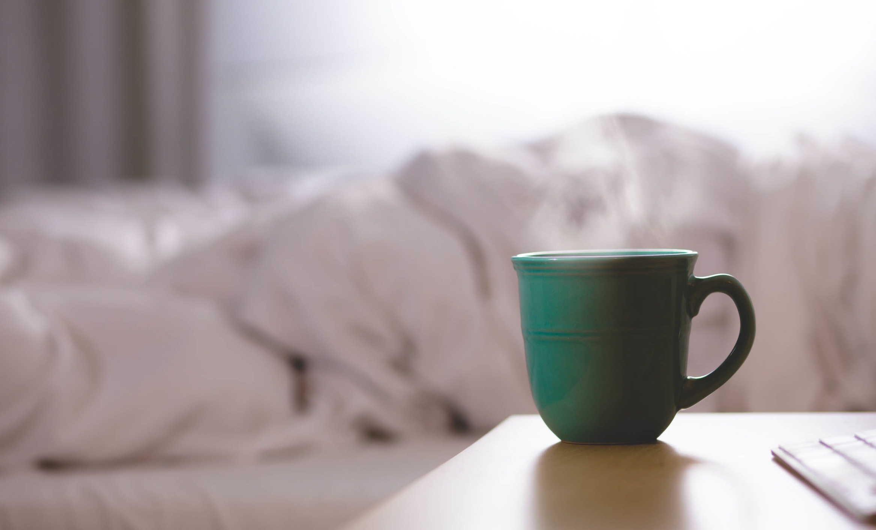
Lesson 8: Self-care is self-love
Self-care deserves to be high on your priority list. Caring for yourself—physically and emotionally—is enjoyable, relaxing, and a wonderful way to lift your spirits. Doing so regularly will set a very healthy routine for yourself, and you will be the one to reap the benefits!
Self-care is a perfect excuse to pamper yourself. Think about it: we've been taught when we do something substantial (get a raise, buy a house, etc.) that we have earned some pampering. We then go get a massage, enjoy a pedicure, or feel we have an excuse to take a nap or lay in the grass and read a book for hours.
However, you're allowed to pamper yourself on an ongoing basis; you are worthy at all times.
Self-care doesn’t necessarily mean you need to “pamper” yourself with a spa day or a bath. It can also be as simple as making the time to eat well or allowing yourself the grace to relax on the couch and watch a movie. Personal development is another form of self-care.
Working on yourself is also important, as we have a need to continue to grow and evolve. One idea is to take an art or cooking class, or a class on another topic you are interested in. Joining a book club is another act of self-care, and is a great way to incorporate more “connection” (which Brene Brown states is necessary for our happiness) into your life.
Sleep is often overlooked as a wonderful way to incorporate self-care. Sleep is critical for stress management, a strong immune system, and overall health. Tissue repair, muscle growth, and protein synthesis all happen when we rest and let our bodies recover.
Many people only get about 6 hours (or less) of sleep per night. It is recommended that for your body to recover from the day's stresses, 8 to 9 hours of sleep is necessary. When you get enough sleep, you will experience increased energy, alertness, focus, and creativity. At the same time, anxiety, irritability and mental exhaustion are reduced.
Did you know that your risk of obesity rises incrementally with the fewer hours of sleep you get? It rises 23% with just six hours of sleep per night, 50% with five hours of sleep per night, and 73% with four hours sleep per night. This is partially due to hormonal disruptions due to lack of sleep. In addition, a lack of sleep makes us crave sugar and simple carbs and because we are exhausted, we tend to make less responsible food choices.
Creating a nighttime ritual is key for quality sleep. Power down all electronics at least an hour before going to bed, drink some decaf tea, take a warm bath, and massage yourself with some lavender oil.
High quality essential oils are another great way to pamper yourself. Whether you massage them on or diffuse them through your home, many oils are helpful in promoting a sense of calm and wellbeing. Give these a try:
- Calming: Cedarwood, Lavender, Roman Chamomile, Tulsi
- Uplifting: Clary Sage, Grapefruit, Lemon, Peppermint
- General wellbeing: Cinnamon, Frankincense

Here are some tips to make your bedroom a tranquil sanctuary:
- Can electronics from the bedroom – this includes TVs, tablets, and phones. The blue light from these devices disrupt your body’s ability to produce melatonin. Melatonin is a hormone your body instinctively produces when it’s nighttime. If your body doesn’t produce enough melatonin, it can’t distinguish between day and night, resulting in tossing and turning.
- Keep your bedroom dark – In addition to removing electronics, keep your curtains closed at night. Outdoor lights from cars, streetlights or the moon can keep you from falling asleep. If you don’t have dark curtains, invest in an eye mask. This keeps the room extremely dark, preparing your body and mind for sleep.
- Invest in a high-quality mattress – One of the main culprits of poor sleep is body pain. Some people don’t realize their mattress may be too hard or too soft. Aim for something with sufficient support. On a budget? Try a textured mattress topper. Additional, be sure to invest in pillows that offer neck support.
- Keep your bedroom cool - If your body overheats, you will break out in a sweat. This can disrupt your sleep and that of your partner. Aim to keep your bedroom between 65-68 degrees Fahrenheit. Not a fan of air conditioning? Invest in a ceiling fan to circulate the air and sleep with a light sheet.
- Wear loose fitting pajamas – If your pajamas are too heavy or tight-fitting, that may cause discomfort, preventing your body from entering a truly relaxed state. Try wearing an old cotton T-shirt. It’s light, airy, and isn’t constricting.
- Place a plant on your nightstand – Unless you’re allergic, having a plant or flowers at your bedside will release oxygen, refreshing the air. They also release water, increasing humidity for improved breathing and purifying the air by removing toxins.
- Declutter your space – Eliminating clutter from the bedroom helps to reduce stress, promoting relaxation. Some items I do suggest you keep in the bedroom are your favorite books, candles, incense, and lavender oil for self-massage.
- Shut down an hour before bed – Not only should you shut down your electronics and the evening news, but your mind as well. This may include a nightly ritual such as a warm bath, hot towel scrub, self-massage with lavender oil or reading a book.
- Write in a journal – Keep a journal by your bed to write down any thoughts from your day. Whether it’s a to-do list for tomorrow, worries you may have, or a gratitude list, get it all out of your mind and on your paper. It’ll help you clear your head and calm your nerves.

TAKE ACTION
- List 3 of your favorite ways to take care of yourself, and commit to these practices daily or weekly.
- In contrast, list 3 things you're doing that may not be serving you. Commit to kicking these to the curb!
- Experiment with Essential Oils listed above!

Need ideas for self-care? Refer to the links below to start implementing today.

Self-care ideas:

https://tinybuddha.com/blog/45-simple-self-care-practices-for-a-healthy-mind-body-and-soul/

https://wholefully.com/50-self-care-ideas/

https://www.mindbodygreen.com/articles/self-care-activities-list-15-ideas-to-try-when-everything-seems-impossible

https://www.psychologytoday.com/blog/shyness-is-nice/201403/seven-types-self-care-activities-coping-stress

